PC Resin

WONDERLITE® is a polycarbonate resin polymerized using the double hydroxy compounds of BPA (bisphenol-A) and the diphenylcarbonates of carbonate compounds with the transesterification (melting) method. Absolutely no phosgene and chlorinated solvents such as dichloromethane were used during the manufacturing process. Our polycarbonate resins are FDA and UL certified.

WONDERLITE® Polycarbonate Resin has excellent transparency, high heat resistance, ultra high impact resistance, dimensional stability, etc., making it suitable for a wide range of applications. All 3C products, electrical and electronic products, precision machinery, instrument products, automotive parts, sporting goods, recreational goods, sanitary hygiene products, CD/DVD related products, etc.

[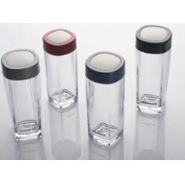](http://image.baidu.com/i?ct=503316480&z=&tn=baiduimagedetail&ipn=d&word=PC%E9%80%8F%E6%98%8E%E6%9D%AF&step_word=&ie=utf-8&in=28591&cl=2&lm=-1&st=-1&pn=2&rn=1&di=115673907910&ln=1722&fr=&&fmq=1392358525507_R&ic=0&s=&se=1&sme=0&tab=&width=&height=&face=0&is=&istype=2&ist=&jit=&objurl=http%3A%2F%2Fwww.huaxiagift.com%2Fuppic%2F20090728102924.jpg)[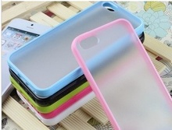](http://detail.1688.com/offer/35181958947.html?spm=a261b.2187593.0.0)